LAB 3
COURSE: COMPUTER NETWORK

TCP AND UDP

Objective
- Stream video between 2 devices with VLC

Streaming Video using UDP
- Download and install VLC into student’s computer (as stream server) and install VLC on smartphone (as client). https://www.videolan.org/
- Stream a video from server using UDP protocol: Media -> Stream -> Choose file (Choose a short video ~ 10 seconds)
- Choose destination as UDP -> Add
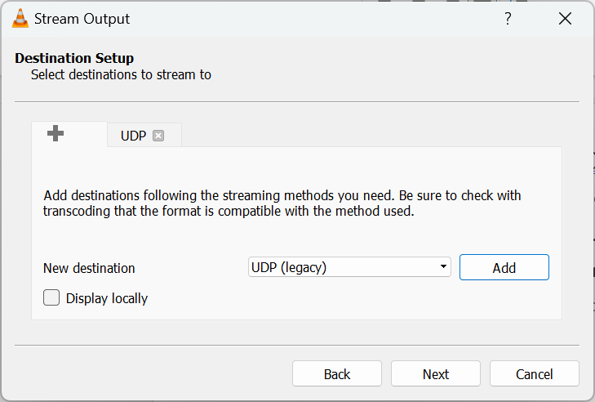
- Add the IP of the smartphone (as client)
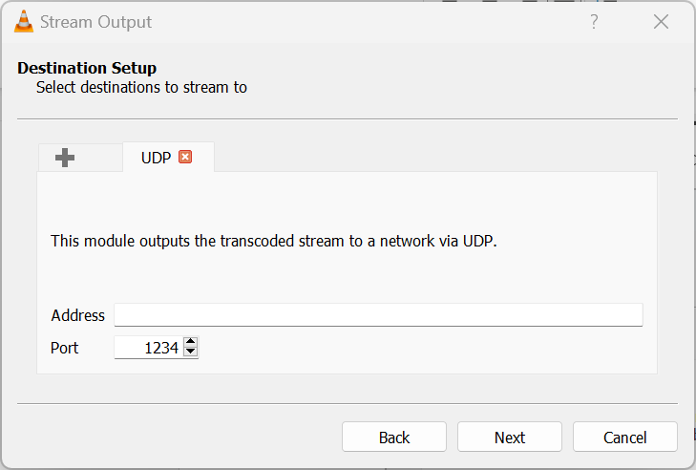
- Open Wireshark and capture.
- Client gets video from server: Network -> Open Network Stream -> Enter the URL: udp://@:1234/
- After the video is finished, stop Wireshark and save the capture with name MSSV-udp.pcap

Streaming Video using TCP
- Stream a video from server using HTTP protocol: Media -> Stream -> Choose file -> Choose destination as HTTP -> Add -> Next -> Stream.
- Open wireshark and capture.
- Client gets video from server: Network -> Open Network Stream -> Enter the URL: http://IPofServer:8080/
- After the video is finished, stop wireshark and save the capture with name MSSV-http.pcap

Analyze UDP
- Open file MSSV-udp.pcap.
- Answer the following questions and capture the screens to verify the answers.

- Using filter to filter the “udp” packet. Select one UDP packet from your trace. From this packet, determine how many fields there are in the UDP header, name these field.
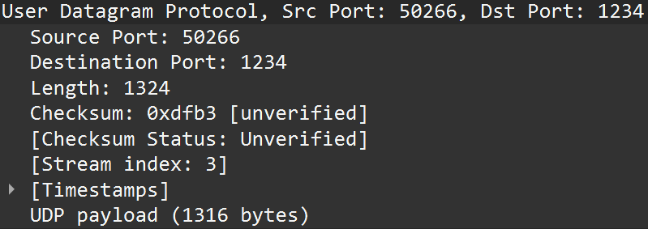
There are 5 fields total in the UDP header:
    - Source Port: 50266
    - Destination Port: 1234
    - Length: 1324
    - Checksum: 0xdfb3
    - UDP payload: 1316 bytes
- By consulting the displayed information in Wireshark’s packet content field for this packet, determine the length (in bytes) of each of the UDP header fields.?
Each UDP header has a length of 8 bytes.
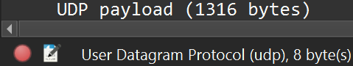
- The value in the Length field is the length of what? Verify your claim with your captured UDP packet.
The length of UDP packet is the sum of UDP header’s length and UDP payload.

- What is the maximum number of bytes that can be included in a UDP payload?
(Hint: the answer to this question can be determined by your answer to 2. above)
The maximum number of bytes that can be included in a UDP payload is (2^16 – 1) bytes plus the header bytes. This gives 65535 bytes – 8 bytes = 65527 bytes.
- What is the largest possible source port number? (Hint: see the hint in 4.)
The largest possible source port number is (2^16 – 1) = 65535.

Analyze TCP
- Open file MSSV-http.pcap
- Type “tcp” into the display filter specification window towards the top of the Wireshark window to filter the TCP packet.
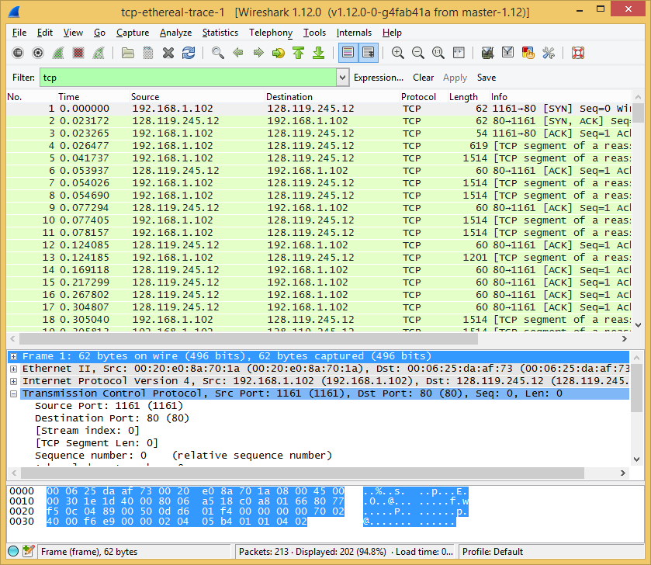
Answer the following questions and capture the screen to verify the answers.
- What is the IP address and TCP port number used by the client?
The client’s IP address is 192.168.172.181, using TCP port number 47154.
- What is0020the IP address server? On what port number is it sending and receiving TCP segments for this connection?
  - Server’s IP address: 192.168.172.111.
  - Server’s TCP port: 8080.
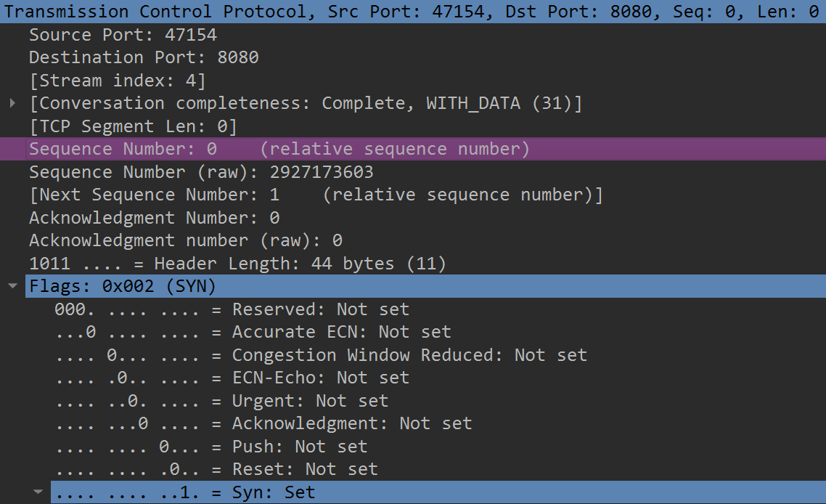
- What is the sequence number of the TCP SYN segment that is used to initiate the TCP connection between the client and server?
The sequence number of the TCP SYN segment has the value of 2927173603 (raw).
What is it in the segment that identifies the segment as a SYN segment?
Hint: Find the field “Flags”
The SYN flag is set to 1 and it indicates that this segment is a SYN segment.
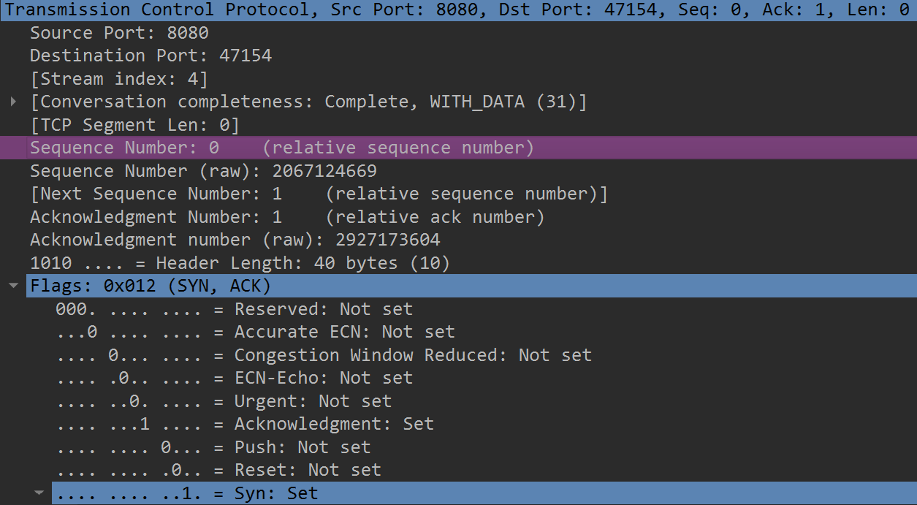
- What is the sequence number of the SYN/ACK segment sent by server to the client computer in reply to the SYN?
The sequence number of SYN/ACK segment has the value of 2067124669 (raw).
What is the value of the Acknowledgement field in the SYNACK segment?
Value of Acknowledgement field is 2927173604 (raw).
How did the server determine that value?
The value of the Acknowledgement field in the SYN/ACK segment is determined by adding 1 to the initial sequence number of SYN segment from the client computer.
What is it in the segment that identifies the segment as a SYN/ACK segment?
The SYN flag and Acknowledgement flag in the segment are set to 1 and they indicate that this segment is a SYNACK segment.
- Find the first 6 segments that server sent to client.
- What are the sequence numbers and the length of the first six segments?
- At what time was each segment sent? When was the ACK for each segment received?
- Given the difference between when each TCP segment was sent, and when its acknowledgement was received, what is the RTT (Round trip time) value for each of the six segments?
Student can answer with the following table:
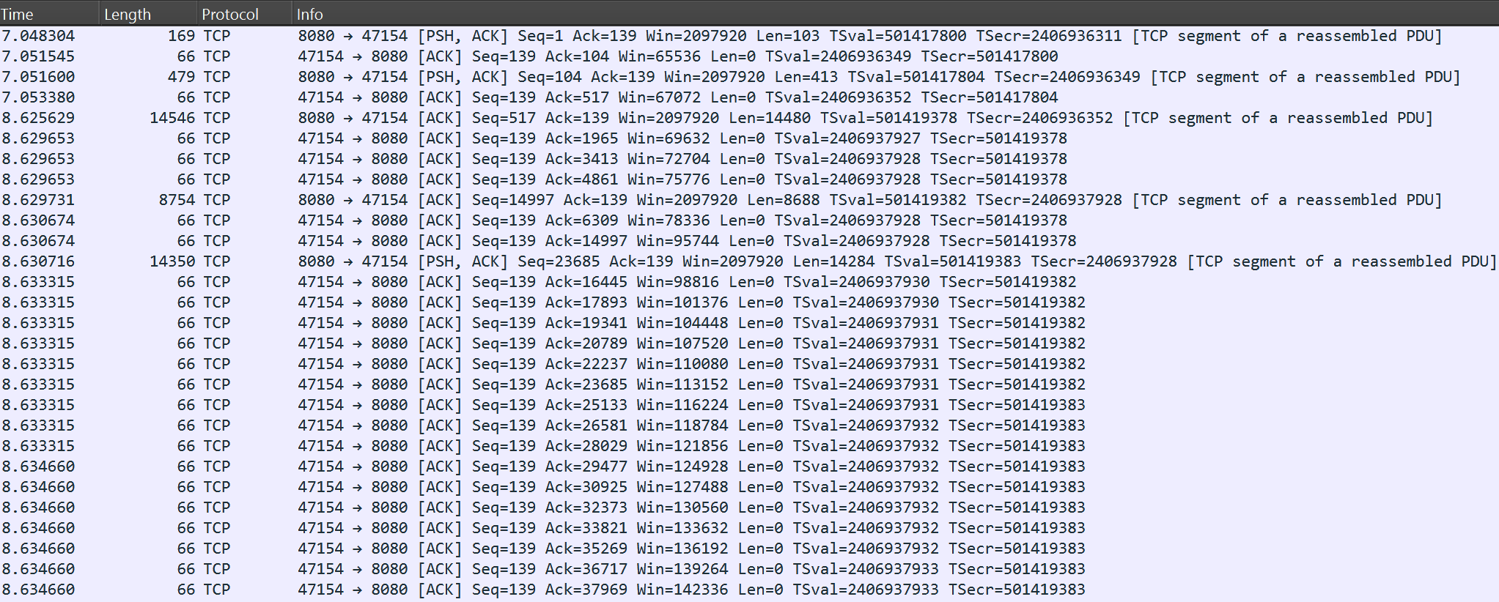
STT | Sequence number | Length (bytes) | Sent time  (s) | Receive ACK time (s) | RTT  (ms)
1 | 1 | 103 | 7.048304 | 104 - 7.051545 | 3.241
2 | 104 | 413 | 7.051600 | 517 - 7.053380 | 1.78
3 | 517 | 14480 | 8.625629 | 14997 - 8.629653 | 4.024
4 | 14997 | 8688 | 8.629731 | 23685 - 8.630674 | 0.943
5 | 23685 | 14284 | 8.630716 | 37969 - 8.634660 | 3.944
6 | 37969 | 36739 | 8.877340 | 74780 - 8.882472 | 5.132
- What is the minimum amount of available buffer space advertised at the received for the entire trace? Hint: The field Windows size “Win=xxxx”
The smallest amount of available buffer space being received is 65535.
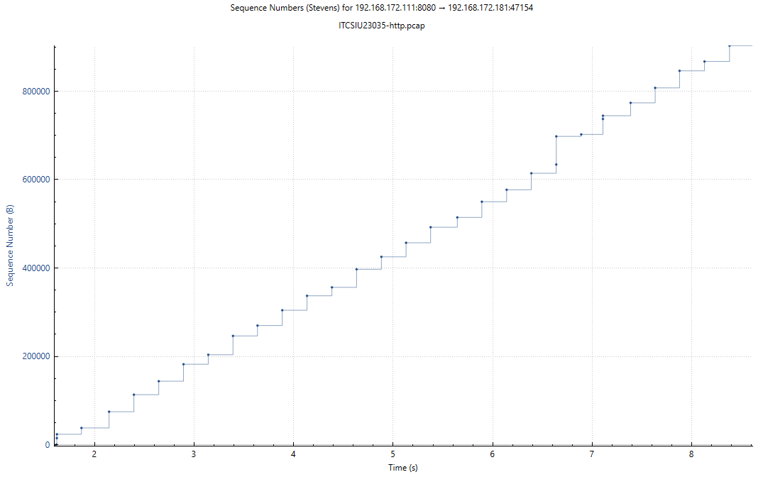
- Are there any retransmitted segments in the trace file? No, there are not any retransmitted segments in the trace file. If it is, there will be two or more dots in a period of a sequence number.
Note: Wireshark has a nice feature that allows you to plot the RTT for each of the TCP segments sent. Select a TCP segment in the “listing of captured packets” window that is being sent from the client to server. Then select: Statistics->TCP Stream Graph -> Time/Sequence (Steven)

Sequence Number (Stevens) Graph
Note that: Each dot in the graph represents the sequence number and sending time of a TCP segment. If there are 2 dots with the same sequence number but they are in different time => there are restransmission.

